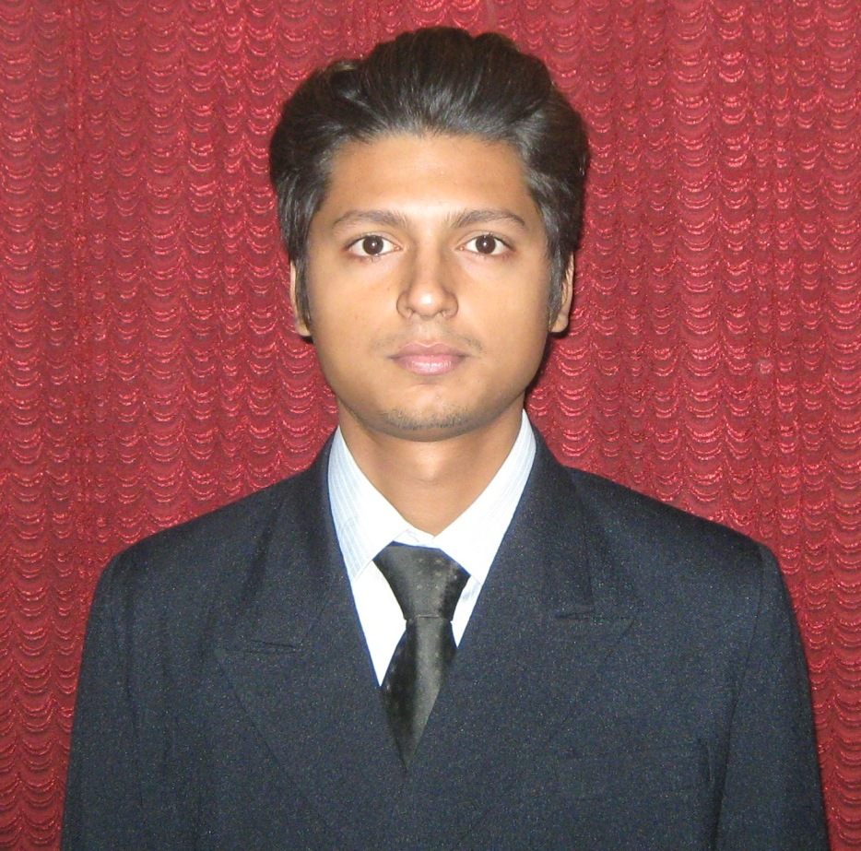
KAUSTUBH SRIVASTAVA
E1/224 Vinay Khand-1
Gomti Nagar
Lucknow
Mobile: 91-9044335643
Kaustubhsrivastava16@gmail.com
Date of Birth:-16/09/1992
CAREER OBJECTIVE
To work in an organization with a challenging environment which enables use of my acquired and inherent skills towards organizational growth together with individual growth.
EDUCATION
Qualifications | Specialization | Board/Univ. | Year | CGPA/%age
M.B.A | Finance & Marketing | Amity University, Lucknow | Pursuing | 7.02
B.COM | Commerce | Lucknow University | 2013 | 53.85
INTERMEDIATE | Commerce | C.B.S.E | 2010 | 61.80
HIGH SCHOOL | SCIENCE | C.B.S.E | 2008 | 64.80

SUMMER INTERNSHIP:
Company Name : (Parag)Lucknow Producer’s Co-operative Milk Union
Ltd., 22, Jopling Road Lucknow.Project Title
Project title : Working Capital Analysis
Period : 8 weeks w.e.f. 1.5.2014 to 30.6.2014
Status : Completed successfully to the satisfaction of my industry
and faculty guides.
DISSERTATION:

Project Title : Impact Of CSR activities by bank on their profitability-A
comparative study of HDFC,SBI and Axis bank.

Period : 151 days w.e.f. 22/12/14 to 22/05/15

Status : Completed Successfully to the satisfaction of my faculty
guides.

EXTRA CURRICULAR ACTIVITIES :
- Achieved the third level seniority by passing examination ‘Tritiya Sopan’ in Bharat Scouts & Guides (2005)
- Successfully participated ‘Trek Adventure Program in Kumaon Hills, Uttaranchal’, conducted by the organization ‘Activists of Voluntary Action for Development of Humanity’ (2004)
- Secured Grade-A in the ‘National Adventure Program’ at National Adventure Institute, Panchmarhi, (MP) under the aegis of Bharat Scouts & Guides (2005)
- Secured 4th position in Regional Sports meet in cricket, conducted by Kendriya Vidyalaya Sangathan, Lucknow Region (2007)
- Attended the Military training programme in Manesar (Gurgaon) at Amity University for developments of team and interpersonal skills (2014)

TECHNICAL SKILLS & ATTRIBUTES:
- Achieved Grade-A in ‘Diploma in Advanced Financial Accounting’ at Lal Bahadur Training Institute, conducted by the Govt of India -2013 which included the following:
- Tally 9.0-2013
- M.S Office 2007,2010-2013
- M.S DOS-2013
INTERESTS / HOBBIES:
- Watching TV, Listening music.
- Internet browsing, Playing Cricket.
SEMINARS / CONFERENCES ATTENDED:
- Attended “From Family Business to Business Family” Seminar at Amity University, Lucknow
- Attended “Elevator’ Pitch” Seminar in Amity University, Lucknow
- Attended “Digital Marketing” Seminar in Amity University, Lucknow.
- Participated in Business Simulation Competition - “Business Turks” at Amity University, Lucknow.

PERSONAL PROFILE:

Name : KAUSTUBH SRIVASTAVA
Father’s Name : Mr. VIVEK KU. SRIVASTAVA
Occupation : SERVICE
Mother’s Name : Mrs. SHASHI LEKHA SRIVASTAVA
Date Of Birth : SEP 16,1992
Gender : MALE
Permanent Address : E1/224 VINAY KHAND-1 GOMTI NAGAR LUCKNOW
Contact No. : +91-9044335643, 9695225511

